**What is MS office. Explain in details**

Microsoft’s suite of productivity products known as Office, or MS Office, is a fixture at businesses around the world. The Office suite includes Word, a word-processing program; Excel, a financial spreadsheet program; Access, a database program; Publisher, for desktop publishing; PowerPoint, a program for creating presentations; Outlook, a program for email and scheduling; OneNote, to keep your notes organized; and InfoPath, an application to track information as it passes through the other applications and through the business.

**Microsoft Word: –** You can use Microsoft Word to create and edit documents such as resume, applications, and letters, school or college assignments professionally.

**Microsoft Excel: –** Microsoft Excel is my favorite application in Microsoft Office suite that anyone can use to perform daily life and business calculation by using logical and mathematical formulas in the spreadsheet. It’s a complete financial management application used by millions of people online and offline. It is very well used in data and information analytics by using filters, conditional formatting, and goal seek and pre-defined templates etc. It is also used to visualize data and information in charts, smart arts, pivot table and much more.

**Microsoft PowerPoint: –** PowerPoint another application of Microsoft packaged with Microsoft Office suite to create presentations using slides to present data and information in meetings, seminars. It means you can use PowerPoint to create project presentation, business plan presentation, school assignments and presentation for seminars etc.

**Microsoft Access: –** You can use MS Access to create database and program to track and manage data and information. It means you can create a database of students, a database of your employees and customer records. You can also track and edit their progress with the profile name, address and everything that is needed for you to collect.

**5. Microsoft Outlook: –** You can use Microsoft Outlook in computer and online as you use Gmail. It is used to send and receive official and personal mail. In this, you can manage your day to day task and save important contacts. The best features that we use each day, is you can access existed emails without an Internet connection. And you can insert all formatting options while writing an email.

**What is MS word ? Explain its features.**

Microsoft Word is a widely used commercial word processor designed by Microsoft. Microsoft Word is a component of the Microsoft Office suite of productivity software, but can also be purchased as a stand-alone product.

Microsoft Office Word allows you to create and edit personal and business documents, such as letters, reports, invoices, emails and books. By default, documents saved in Word are saved with the .docx extension. Microsoft Word can be used for the following purposes −

* To create business documents having various graphics including pictures, charts, and diagrams.
* To store and reuse readymade content and formatted elements such as cover pages and sidebars.
* To create letters and letterheads for personal and business purpose.
* To design different documents such as resumes or invitation cards etc.
* To create a range of correspondence from a simple office memo to legal copies and reference documents.

**Features**:

* **SPELLING check**  – You can correct your spelling errors all in one go, to ensure you haven’t left any stone unturned. This can be done by running a full Word spell check from the Review tab, Proofing group, Spelling and Grammar button (or press the F7 keyboard shortcut). When using the main Spelling and Grammar dialog box, words in your document which are not found in Word's dictionary will be listed in the Not in Dictionary box. Suggestions will be presented below with the first suggestion selected.
* **MAIL MERGE** – [**This feature**](http://office.microsoft.com/en-gb/outlook-help/using-contacts-for-mail-merge-HA001186695.aspx) allows us to send out bulk emails, but consequently with unique elements. For example, we could produce a series of labels or envelopes for a large mailing, an email or letter that includes names and addresses and other details or a ‘directory’. Users simply create one document that contains the information that will be the same in each version, and then add placeholders for the information that will be unique to each version.
* **WATERMARKS** – If you’re sending an important document or draft sample, you want to be able to protect your content without having to edit much of it. Insert a watermark specific to your objectives via the page layout button. You can also customise your own watermark, and also insert your own picture.

**HEADER & FOOTER**– It’s important to use the space in your header and footer to save space in other areas of your document. This also makes your file have a professional look that can include the page numbers across the whole document for example

* **Shapes and Smart Art**  feature is used to insert rectangular, circle, arrows, charts, lines, symbols based on the demand of the document.  You can visually communicate information by using process diagrams, hierarchy diagrams, list diagrams, relationship diagrams such diagrams is very important in which we can use to display organizational structure, processes such as (Input->Processor->Output). SmartArt is easy to understand and teach any complex problem. The option is also available in Microsoft PowerPoint.

following is the basic window which you get when you start the Word application. Let us understand the various important parts of this window..

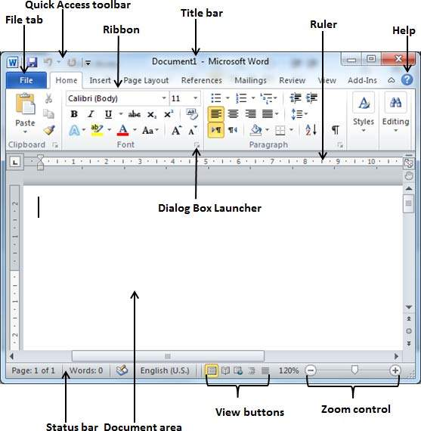

File Tab

The File tab replaces the Office button from Word 2007. You can click it to check the **Backstage view**. This is where you come when you need to open or save files, create new documents, print a document, and do other file-related operations.

Quick Access Toolbar

This you will find just above the **File tab**. This is a convenient resting place for the mostf requently used commands in Word. You can customize this toolbar based on your comfort.

Ribbon

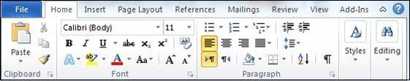

Ribbon contains commands organized in three components −

* **Tabs** − These appear across the top of the Ribbon and contain groups of related commands. Home, Insert, Page Layout are examples of ribbon tabs.
* **Groups** − They organize related commands; each group name appears below the group on the Ribbon. For example, group of commands related to fonts or group of commands related to alignment, etc.
* **Commands** − Commands appear within each group as mentioned above.

Title bar

This lies in the middle and at the top of the window. Title bar shows the program and document titles.

Rulers

Word has two rulers - a horizontal ruler and a vertical ruler. The horizontal ruler appears just beneath the Ribbon and is used to set margins and tab stops. The vertical ruler appears on the left edge of the Word window and is used to gauge the vertical position of elements on the page.

## View Buttons

The group of five buttons located to the left of the Zoom control, near the bottom of the screen, lets you switch through the Word's various document views.

* **Print Layout view** − This displays pages exactly as they will appear when printed.
* **Full Screen Reading view** − This gives a full screen view of the document.
* **Web Layout view** − This shows how a document appears when viewed by a Web browser, such as Internet Explorer.
* **Outline view** − This lets you work with outlines established using Word’s standard heading styles.
* **Draft view** − This formats text as it appears on the printed page with a few exceptions. For example, headers and footers aren't shown. Most people prefer this mode.

## Go To Command

Press the **F5** key to use the **Go To** command. This will display a dialogue box where you will have various options to reach to a particular page.

Normally, we use the page number, the line number or the section number to go directly to a particular page and finally press the **Go To** button.

Selecting a text is one of the most important skills required while editing a word document. You can perform various operations on a selected text; you can delete the selected text, copy it, move it, apply formatting to it, change its capitalization, etc.

The most common method of selecting a text is to click and drag the mouse over the text you want to select. Following table lists down a few other simple methods that will help you in selecting text in different scenarios −

|  |  |
| --- | --- |
| **S.No** | **Component & Selection Method** |
| 1 | **Selecting text between two points**  Click at the start of the block of text, hold down **Shift**, and click at the end of the block. |
| 2 | **Selecting a single word**  Double-click anywhere on the word you want to select. |
| 3 | **Selecting a paragraph**  Triple-click anywhere on the paragraph you want to select. |
| 4 | **Selecting a sentence**  Hold down the **Ctrl** key and click anywhere in the sentence you want to select. |
| 5 | **Selecting a column of text**  Hold down Alt, click and hold the mouse button, and drag over the column you want to select. |

Note that only one part of the document can be in the selected state. If you have one portion of the document in selected state and as soon as you try to select any other part of the document, previous part will automatically be de-selected.

## Using the Keyboard

Keyboard provides very good support when you want to select various components of the document as described in the following table −

|  |  |
| --- | --- |
| **S.No** | **Key & Selection Method Selecting Text** |
| 1 | **Ctrl + A**  Press **Ctrl + A** keys to select the entire document. |
| 2 | **Shift**  Keep pressing the **Shift** key and use any of the arrow keys to select the portion of text. |
| 3 | **F8**  Press **F8** and then use any of the arrows keys to select the portion of text. |
| 4 | **Ctrl + Shift + F8**  Press **Ctrl + Shift + F8** and then use any of the arrows keys to select column of the text. |

## Copy & Paste Operation

The **Copy** operation will just copy the content from its original place and create a duplicate copy of the content at the desired location without deleting the text from it's the original location. Following is the procedure to copy the content in word −

**Step 1** − Select a portion of the text using any of the text selection methods.

**Step 2** − You have various options available to copy the selected text in clipboard. You can make use of any one of the options −

* **Using Right-Click** − When you right-click on the selected text, it will display the **copy** option, click this option to copy the selected content in clipboard.
* **Using Ribbon Copy Button** − After selecting text, you can use the copy button available at the ribbon to copy the selected content in clipboard.
* **Using Ctrl + c Keys** − After selecting a text, just press **Ctrl + c** keys to copy the selected content in clipboard.

**Step 3** − Finally click at the place where you want to copy the selected text and use either of these two simple options −

* **Using Ribbon Paste Button** − Just click the Paste button available at the ribbon to paste the copied content at the desired location.
* **Using Ctrl + v Keys** − This is simplest way of pasting the content. Just press **Ctrl + v** keys to paste the content at the new location.

Find and replace option

We assume you are an expert in searching a word or phrase in a word document as explained above. This section will teach you how you can replace an existing word in your document. Following are the simple steps −

**Step 1** − Click the **Replace option** in the **Editing group** on the Home tab or press **Ctrl + H** to launch the **Find and Replace** dialog box shown in Step 2

 Type a word which you want to search. You can also replace the word using the **Find and Replace** dialog box as in the following screenshot −

Type a word which you want to search. You can also replace the word using the **Find and Replace** dialog box as in the following screenshot −

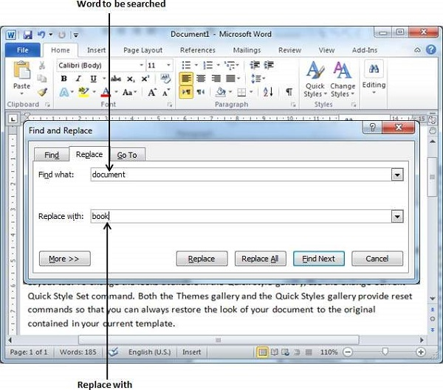

**Step 3** − Click the **Replace** button available on the **Find and Replace** dialog box and you will see the first occurrence of the searched word would be replaced with the replace with word. Clicking again on **Replace** button would replace next occurrence of the searched word. If you will click **Replace All**button then it would replace all the found words in one go. You can also use **Find Next** button just to search the next occurence and later you can use **Replace** button to replace the found word.

## Check Spelling and Grammar using Review tab

Here is the simple procedure to find out the spelling mistakes and fix them −

**Step 1** − Click the Review tab and then click the **Spelling & Grammar**button.

A Spelling and Grammar dialog box will appear and will display the wrong spellings or errors in grammar. You will also get suggestions to correct as shown below −

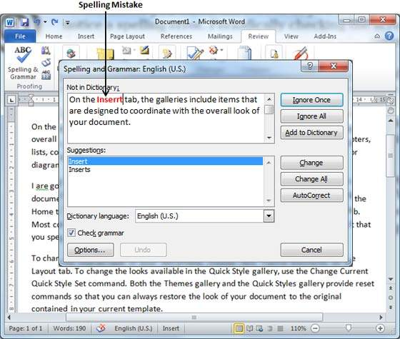

Now you have following options to fix the spelling mistakes −

* **Ignore** − If you are willing to ignore a word, then click this button and Word ignores the word throughout the document.
* **Ignore All** − Like Ignore, but this ignores all occurrences of the same misspelling, not just once but throughout the document.
* **Add to Dictionary** − Choose **Add to Dictionary** to add the word to the Word spelling dictionary.
* **Change** − This will change the wrong word using the suggested correct word.
* **Change All** − Like Change, but this changes all occurrences of the same misspelling, not just once but throughout the document.
* **AutoCorrect** − If you select a suggestion, Word creates an **AutoCorrect** entry that automatically corrects this spelling error from

**tep 3** − Select one of the given suggestions you want to use and click the **Change** option to fix the spelling or grammar mistake and repeat the step to fix all the spelling or grammar mistake.

**Step 4** − Word displays a dialog box when it finishes checking for spelling and grammar mistakes, finally Click **OK**.

**INSErT Picture**

### How to Insert Pictures Into Word

The easiest method to insert a picture is to drag the photo from its folder directly into the Word document. However, the customary method is to use Word's **Insert**menu.

1. Click **Insert**.
2. Select **Pictures** or **Picture** If you're using Word Online, click **Picture**or **Online Pictures**instead.
3. Click the **image** to insert into the document. Insert several images simultaneously into a Word document by selecting all of them at once.

### How to Compress an Image in Word

If you want to use Word to edit photos, or if you frequently include images in your Word document, you should familiarize yourself with the compression options. Compressing Word photos will help you limit the file size of documents that contain images.

1. Open the **Picture Format** tab in the menu if it isn't already open.
2. Click **Compress Pictures** from the **Adjust** area of the menu.

# [How to Add a Caption to an Image in Word 2013](https://www.howtogeek.com/166301/how-to-add-a-caption-to-an-image-in-word-2013/)

How to add a caption, select a picture in your document and click the References tab.

In the Captions section, click Insert Caption.

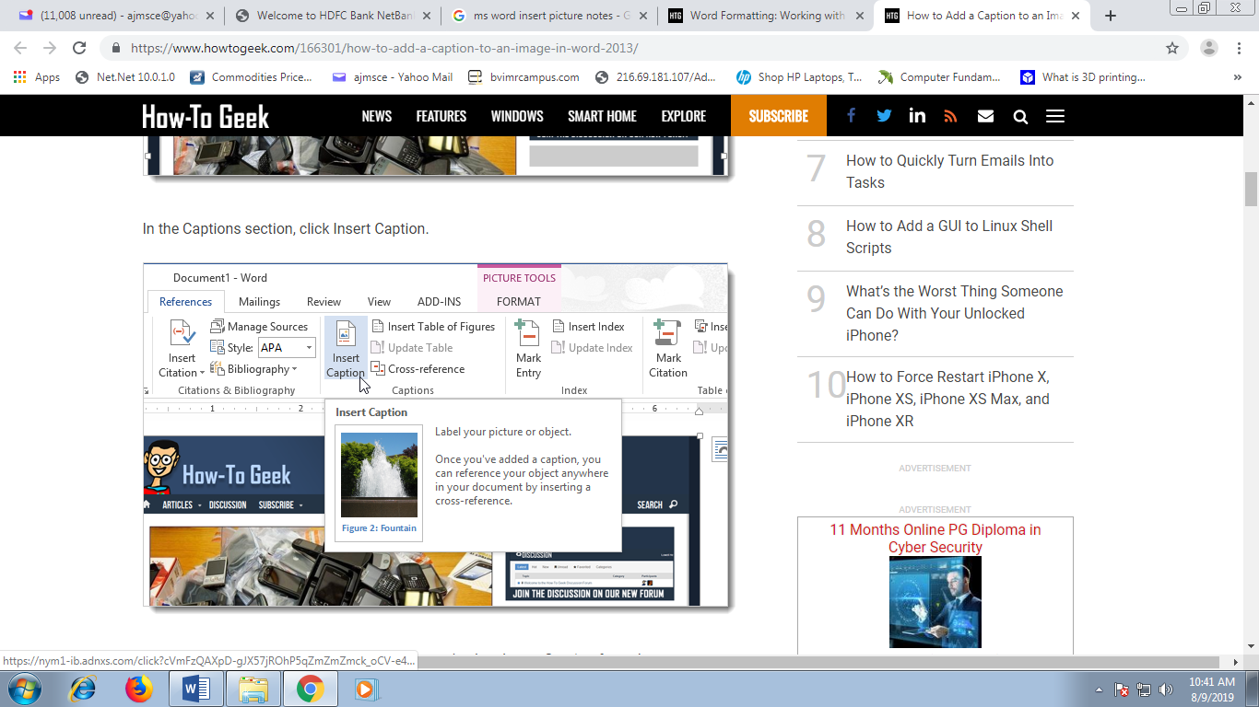

# **How to create and customize tables in Microsoft Word**

Microsoft now provides different methods for creating tables: the Graphic Grid, Insert Table, Draw Table, insert a new or existing Excel Spreadsheet table, and Quick Tables, plus an option for converting existing text into a table.

Under the Insert tab, click the *Table* button. The Insert Table dialog box will open, showing a basic grid pattern as well as traditional menu options below it. Place your cursor on the first cell in the grid and slide it down and over until you highlight (for this example) four columns and five rows, then click once.

Notice that once the table is created, a new option called Table Tools appears on the Ribbon bar with two new tabs: Design and Layout. See the Layout and Design section below for details regarding these options.

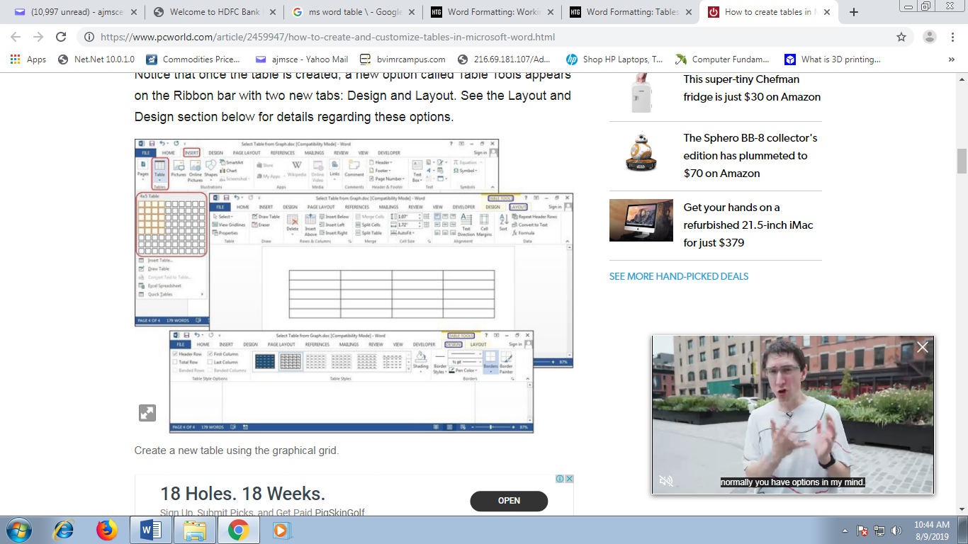

**Insert Table**

Click *Insert > Tables > Insert Table* from the dropdown menu. In the Insert Table dialog box, enter the number of columns and rows you want in this table (four columns and five rows). In the AutoFit Behavior panel, select *Auto*, or click the down arrow to choose a specific size. You can also choose AutoFit to Contents (produces narrow columns that expand as you add data) or AutoFit to Window (expands the table to fit the document size).

**Draw Table**

Click *Insert> Tables > Draw Table*. The cursor turns into a pencil, which you drag down and across to draw a box. Don’t worry about the exact dimensions; you can modify it any time.

Once the box is created, position the cursor inside the box and draw lines over and down for the columns and rows (one at a time). Don’t worry about crooked lines, either—Word straightens them as you draw.

**Excel Spreadsheet (create In Word)**

Click *Insert > Tables > Excel Spreadsheet*. An Excel spreadsheet inserts at your cursor location. You can continue using Excel and its menus and commands, but after you enter your data it converts to a non-editable graphic.

If you want to add, delete, or modify the spreadsheet, right-click anywhere inside the worksheet graphic, select *Worksheet Object*from the dropdown menu, then click *Edit*. The original spreadsheet reappears for editing. Notice the top menu has changed to an Excel menu for edits.

**Quick Tables**

Quick Tables are Word’s table templates. In addition to the nine templates provided, you can create your own designs and save them to the Quick Tables Gallery to use later. Click *Insert > Tables > Quick Tables*. Select a table template from the Quick Tables menu, then modify it to fit your project.

**Convert Text to Table**

The table tools can also make lists a lot easier to customize and even reorganize later. For our example, we'll turn a classic contact list into a table, using a list of names—first, middle, last—plus the city, state, region, and profession of each person on the list.

# **The Types of Views Available in MS Word**

he various views display the different ways your document will look on paper, a monitor and the Internet. Word's multiple view capability is a helpful tool accessible from the program's toolbar.

## Web layout

Microsoft Word's Web view lets you see how your document will look as a website. Any embedded graphics, backgrounds and borders will appear just as the objects would appear within an Internet browser. You can still edit your Word document while in this view as well as save your document.

## Print layout

Ideal when setting margins and formatting your Word document for printing to your system's or a commercial printer, the Print view displays your document exactly the way it will look when printed from your printer. This view also displays footer, header and footnote information. Your document is also editable in this view.

## Outline

The Outline view adds bullets, nested levels and indented lines within your document to aid in editing, moving, copying and pasting elements within the document. This view is ideal when working with multiple-page documents such as books, manuscripts and research papers.

## Normal

The Normal view, Microsoft Word's default view, is ideal when working with text and graphics that are basic or when you don't plan on outputting to a Web server or commercial printer. This view does not display header/footer and margin information, but you can edit your document in this view as well as save it.

### Draft View

Use draft view to view the document as a draft, to enable you to quickly edit the text. Certain elements of the document, such as headers and footers, will not be visible in this view.

**Read Mode** to hide the writing tools and menus and to leave more room for the pages themselves. Read Mode automatically fits the page layout to your device, using columns and larger font sizes, both of which you can adjust.

**Mail merge** is a feature within most data processing applications that enables users to send a similar letter or document to multiple recipients. It enables connecting a single form template with a data source that contains information about the recipient’s name, address and other predefined and supported data.

Only specific sections of each document varies and is personalized. The documents Word can create with mail merge include bulk [labels](https://support.office.com/en-us/article/labels-276a2cd1-74d2-43d0-ab5a-b90460358ad5), [letters](https://support.office.com/en-us/article/letters-d7686bb1-3077-4af3-926b-8c825e9505a3), [envelopes](https://support.office.com/en-us/article/envelopes-654d563e-e9d6-47b5-b7bd-539064938b9d), and [emails](https://support.office.com/en-us/article/emails-0f123521-20ce-4aa8-8b62-ac211dedefa4). There are three documents involved in the mail merge process:

* Your main document
* Your data source
* Your merged document

1. In a blank Microsoft Word document, click on the **Mailings** tab, and in the **Start Mail Merge** group, click **Start Mail Merge**.   
   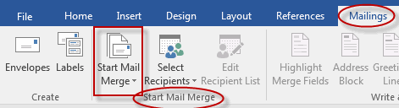

1. Click **Step-by-Step Mail Merge Wizard**.  
   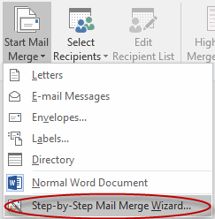

1. Select your document type. In this demo we will select **Letters**. Click **Next: Starting document**.   
   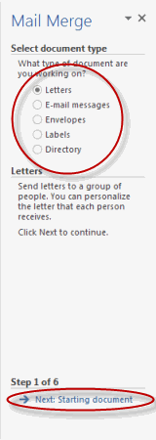

1. Select the starting document. In this demo we will use the current (blank) document. Select **Use the current document** and then click **Next: Select recipients**.   
   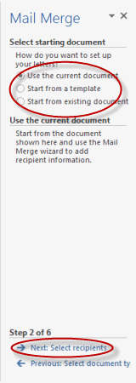  
   * Note that selecting **Start from existing document** (which we are not doing in this demo) changes the view and gives you the option to choose your document. After you choose it, the Mail Merge Wizard reverts to **Use the current document**.
2. Select recipients. In this demo we will create a new list, so select **Type a new list** and then click **Create**.   
   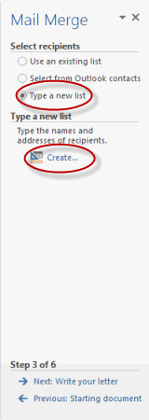  
   * Create a list by adding data in the **New Address List** dialog box and clicking **OK**.   
     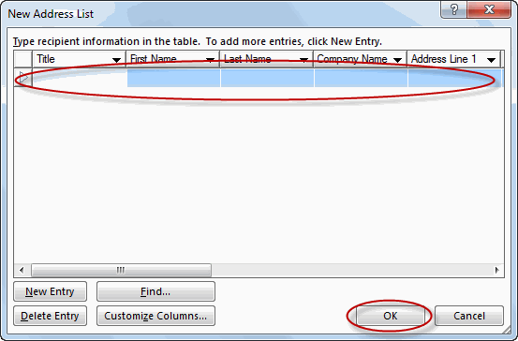

* + Save the list.

* + Note that now that a list has been created, the Mail Merge Wizard reverts to **Use an existing list** and you have the option to edit the recipient list.  
    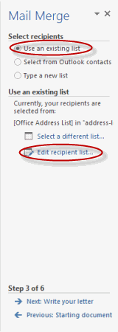

* + Selecting **Edit recipient list** opens up the **Mail Merge Recipients** dialog box, where you can edit the list and select or unselect records. Click **OK** to accept the list as is.   
    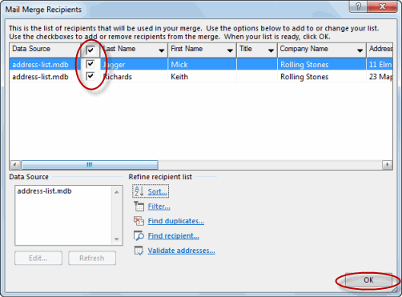

* + Click **Next: Write your letter**.   
    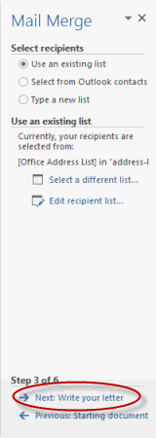

1. Write the letter and add custom fields.
   * Click **Address block** to add the recipients' addresses at the top of the document.   
     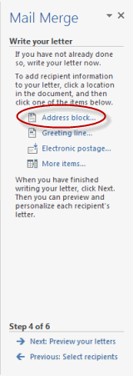

* + In the **Insert Address Block** dialog box, check or uncheck boxes and select options on the left until the address appears the way you want it to.   
    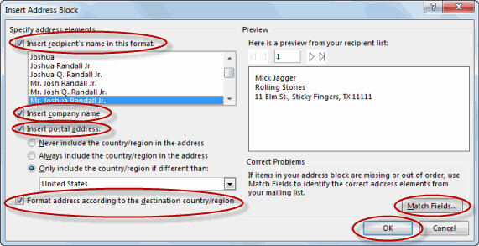
  + Note that you can use **Match Fields** to correct any problems. Clicking **Match Fields** opens up the **Match Fields**dialog box, in which you can associate the fields from your list with the fields required by the wizard.   
    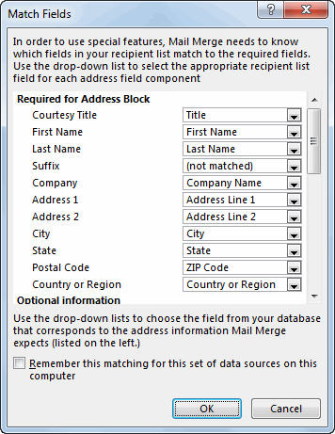

1. Press Enter on your keyboard and click **Greeting line...** to enter a greeting.   
   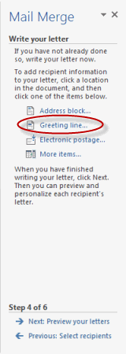

1. In the **Insert Greeting Line** dialog box, choose the greeting line format by clicking the drop-down arrows and selecting the options of your choice, and then click **OK**.   
   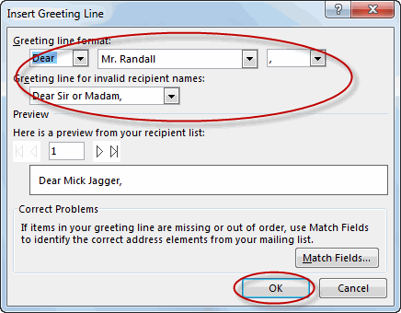

1. Note that the address block and greeting line are surrounded by chevrons (« »). Write a short letter and click **Next: Preview your letters**.   
   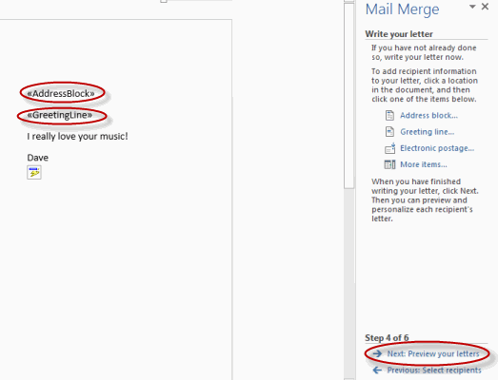

• Preview your letter and click **Next: Complete the merge**.   
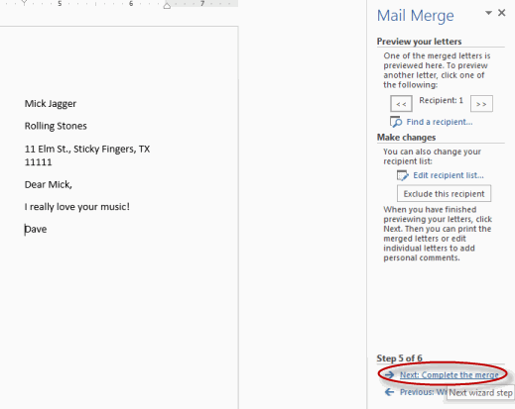

• Click **Print** to print your letters or **Edit individual letters** to further personalize some or all of the letters.   
